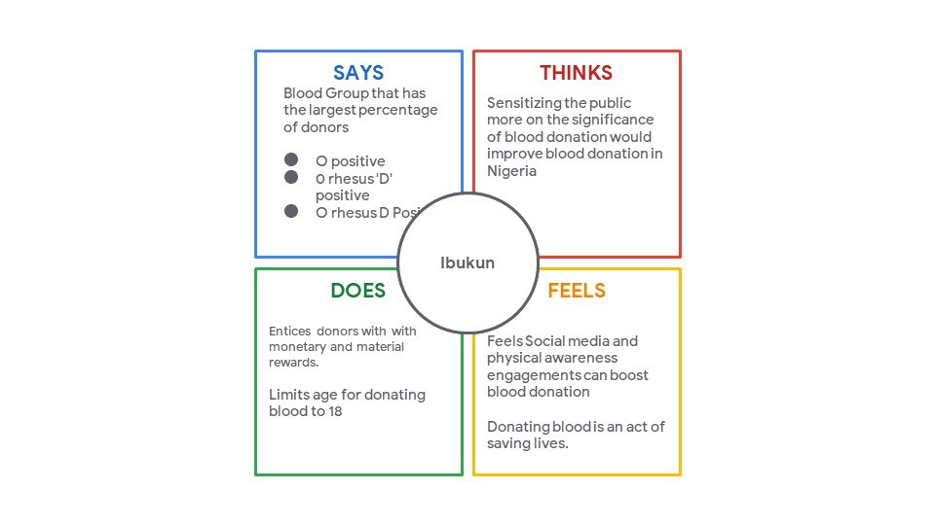**Empathy Map for Plasma Donor Application:**

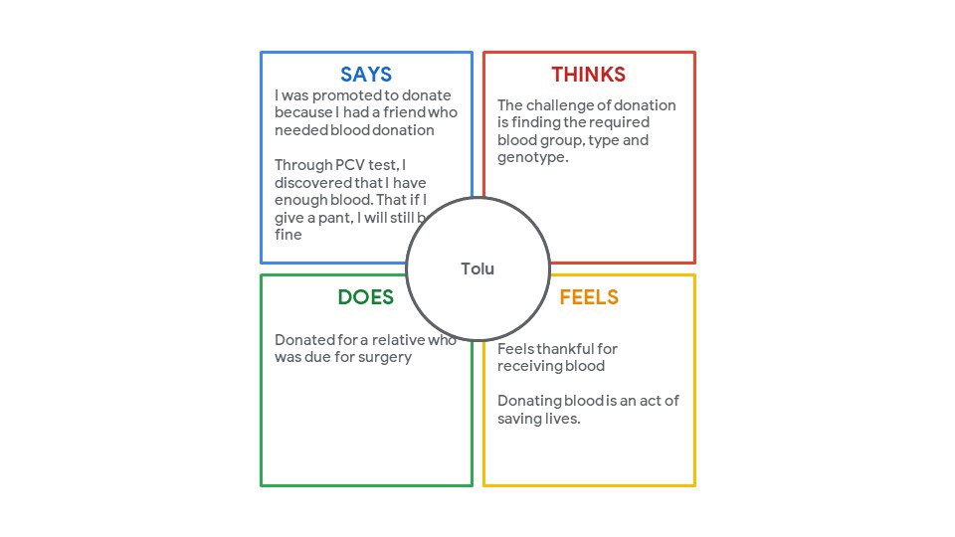



An empathy map was needed majorly for two reasons:

1. To align the team members on a single understanding of the user, their needs and motivations.
2. To identify key insights.

**Insights**:  
On analysing the empathy map we discovered some new insights:

* Donors are scared about their safety on returning back to the hospital.
* People want to secure a plasma donor for themselves in advance in case of any emergency.
* Most of them are ready to donate but don’t have much knowledge about the therapy.

**User Personas**

After analysing the empathy map and the insights carefully, I created user personas and divided the users into two main categories:

1. Seekers (Relatives of the patients seeking a plasma donor)
2. Donors (People who are ready to donate their plasma)